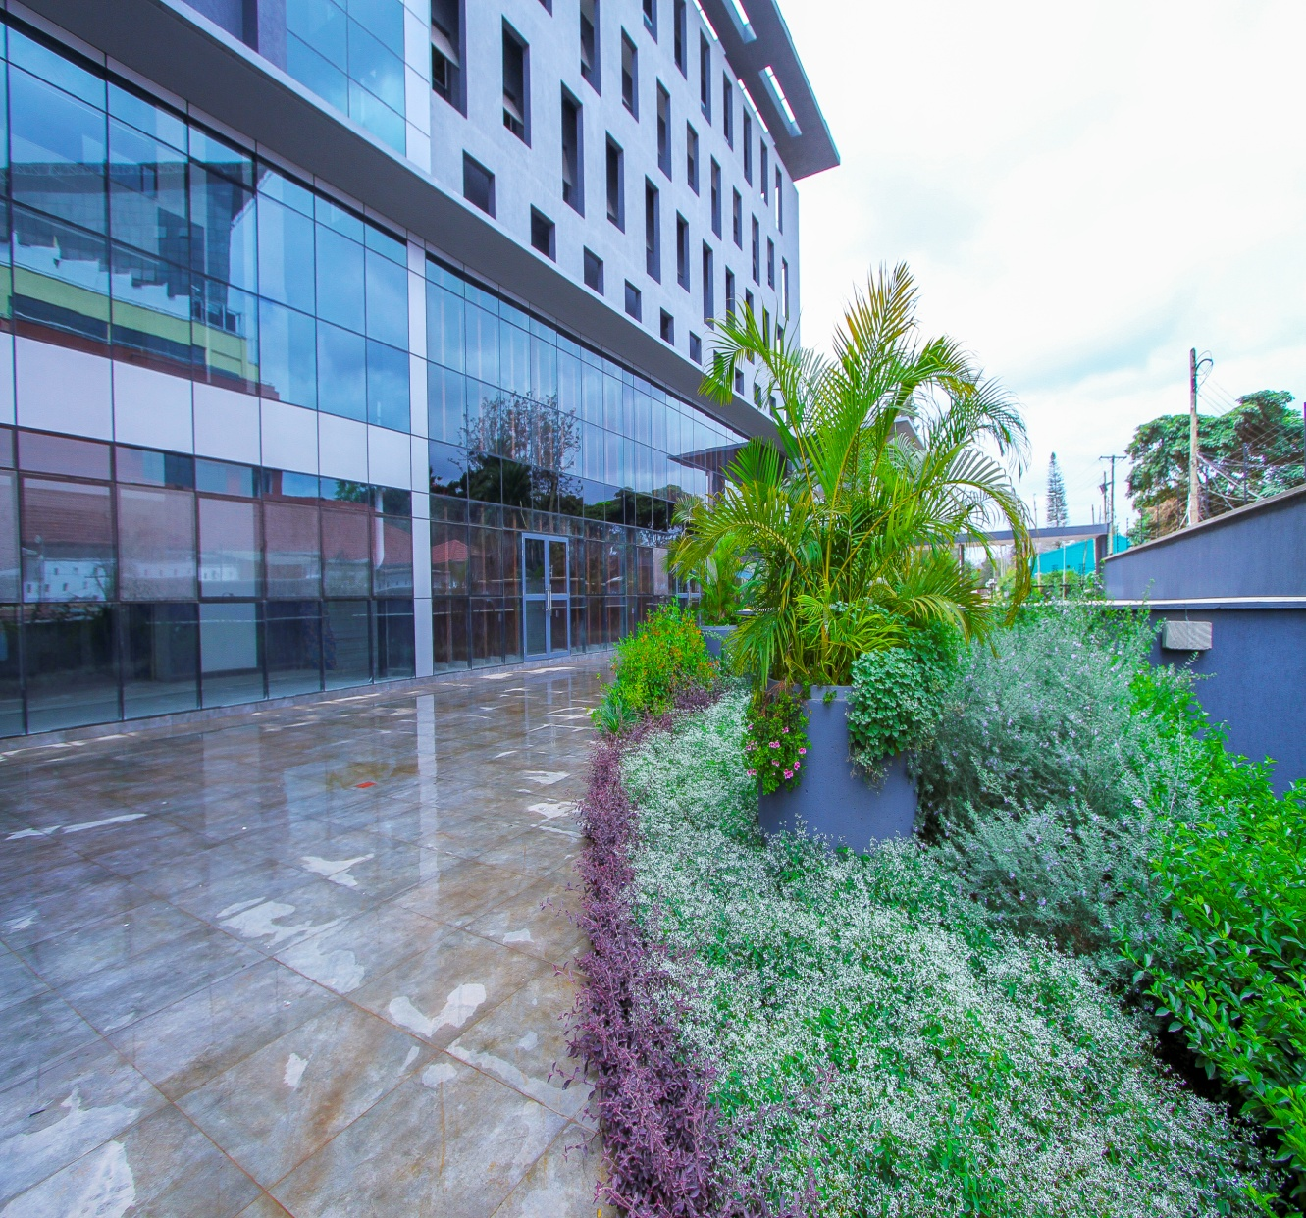

|  |
| --- |
| Website plan |
| Website plan revised |
| Ian Gitata |

Website plan report

## key points from the meeting and new directives and goals for the website

Based on what was agreed upon on the meeting the website will undergo significant changes according to the directive of the MD we shall not complicate the website at all.

The main audience we intend to capture is commercial clientele or potential clients with big projects that require landscape services. we do not intend the website to market any residential projects in its portfolio unless they are based on residential community development projects in this case large residential projects! So what this implies is that our portfolio page will be based upon marketing key commercial projects e.g. Westgate, two rivers, Garden city, Tiara ii offices, Mashiara park, Kihingo village, Vienna court etc.

The background color will follow the same color scheme as the brochure which is the green background. The home page will give a brief description of who we are what is our mission and vision statement and also it will have Botanica logo on the top left and underneath the logo will be the full company name.

The pages that will be featured are in the next page.

Based on the established timelines we expect the website to be delivered in a month's time. we will have scheduled meetings to approve of the website layout when the website is being built. the next meeting is a presentation from the web developer.

The tasks that are required as of now require gathering web content such as photo's selection with a description of the project and time it began/finished, gathering the amended company profile and creating a more web friendly service process chart for our services page which will serve as an info graph.

we will need to amend a brochure for it to be downloadable on the website and sent to the web developer.

SKELETON STRUCTURE OF PANEL LINKS TO THE WEBSITE AND WEBSITE CONTENT

**1. The Firm**

This page shall contain an introductory statement, brief history, vision and mission and lastly our nursery garden world will come into the page about the firm. Garden world nursery in short will have very small details showing that we have capacity to fulfill project needs and it will also have photos showing our nursery below the description in a slide show style.

**2. Our services**

This will show our business process model for the audience and it will showcase on a second page link page

**3.Contacts**

The page will have a contacts also showing Google maps image link and also description of location p.o. box. the page will also have icons for the houzz link instagram and facebook for social media and will have our office hours etc

**4. Projects page**

it shall have a very small description of projects and their status this status shall be represented in the brief description

Website item layout and contents

|  |
| --- |
| **Content**  **approval and analysis** |
| Firm page | Introductory statement | Mission & vision statement | Brief history | Page layout approval | Garden world nursery |

|  |  |
| --- | --- |
| **Info chart**  **style** | **Will we develop the info chart?** |
| **Our services** | our services are represented by an info chart | Before the info chart a short sentence shall say that below this are our service procedure | A style must be selected to represent the info chart in a professional style | The chart itself depending on the how we desire the look can either be developed by us or the web developer.  This page shall also have download the brochure link | |

notes:  
WEBSITE ITEM LAYOUT AND CONTENTS

notes:

|  |  |  |  |
| --- | --- | --- | --- |
| Projects page | Page will have short description of who are our key clients in this case we will say hospitality projects commercial projects e.g. office parks, malls etc | Page will feature projects that are selected as key identifiable projects | Page will have details of ongoing and finished projects of which have been selected |

notes:

|  |  |  |  |  |  |
| --- | --- | --- | --- | --- | --- |
| Contacts | Will contain office hours and office mobile numbers | Contain Google maps | Contact us form which will be sent to our email at info@ botanica.co.ke | Will contain image links of our houzz, instagram and facebook pages |  |

Notes